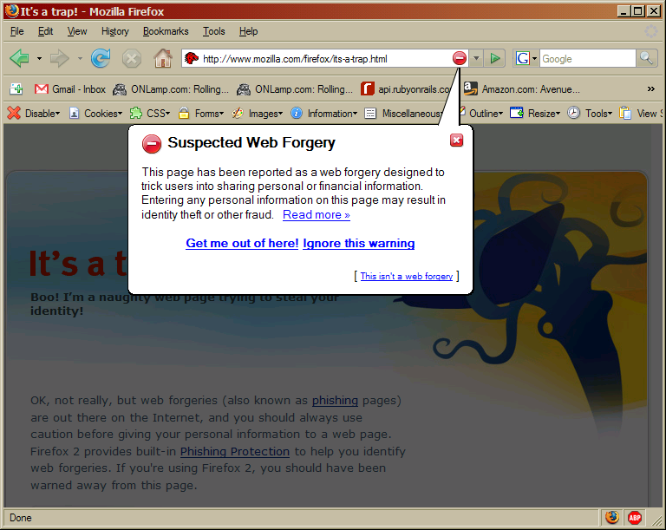

Summary
I don’t use Internet Explorer. I do use Firefox, which comes with good phishing protection built in. Unlike IE7, the phishing protection in Firefox doesn’t send every website you visit to Microsoft for checking. Instead, periodically, Firefox updates a blacklist of websites, and it checks the sites you visit internally against that list. Firefox’s phishing protection is built by Google, and it’s very good because of the amount of time that went into making it good. It’s available as an extension to Firefox 1.5 and it comes with Firefox 2 (came out Wednesday). I think it’s great (should suffice for this lab, I think).

